Proj_3
Superstore_3
Bullet Graph
- used to compare target vs actual values for a dimension
- Bullet Graph doesn't need dates
- difficult to understand
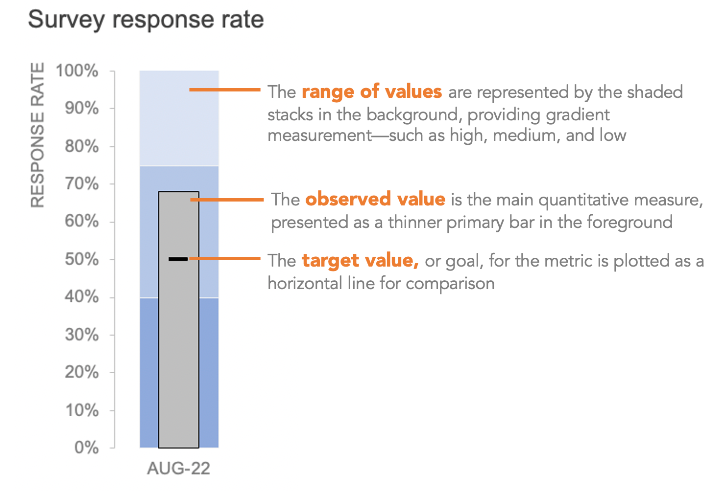
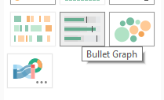
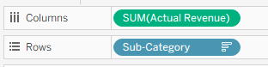
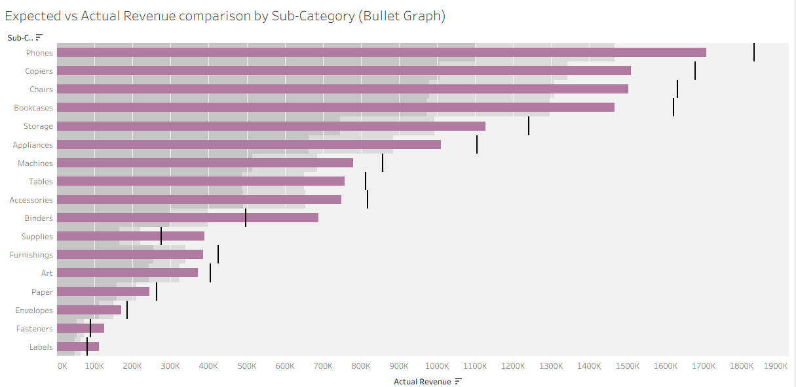Expected vs Actual Revenue comparison by Sub-Category (Bullet Graph)

1) Expected vs Actual Revenue comparison by Region (Bullet Graph)
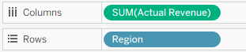
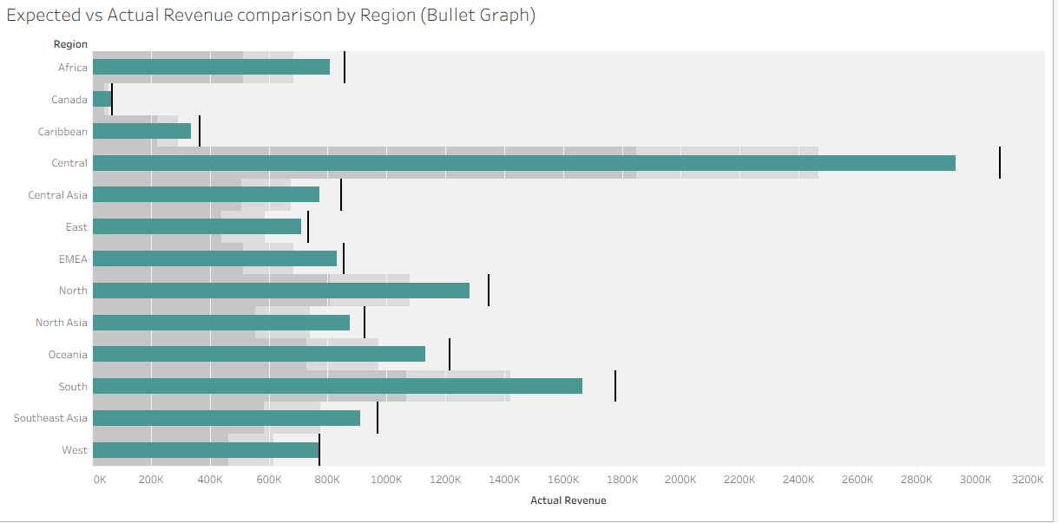
2) Expected vs Actual Profit comparison by Sub-Category (Bullet Graph)
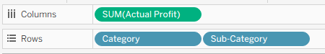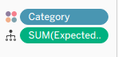

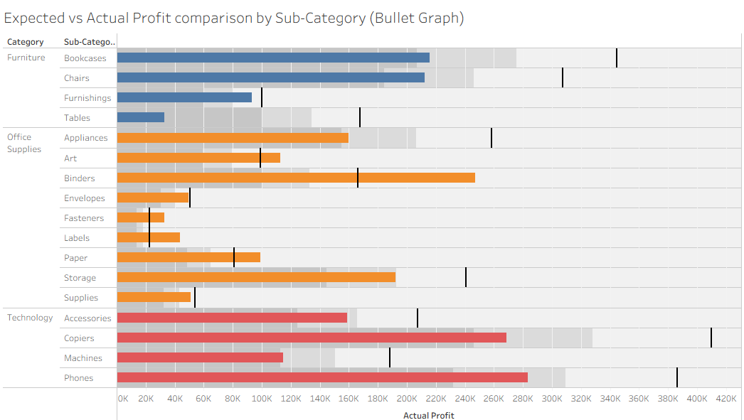
3) Expected vs Actual Profit comparison by Region (Bullet Graph)
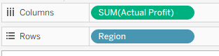
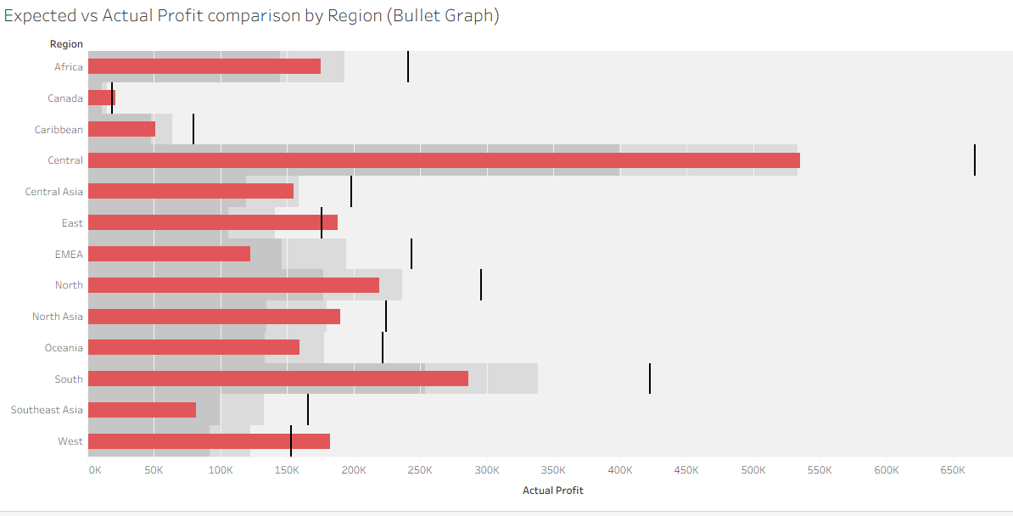

Scatter plot is used to compare two numeric business values on X & Y axis to find possible correlation between them. it helps to create trend line equation and R square.
Line equation
Y = mX + c where m is the slope and c is constant.
Two types of scatter plot
1) with aggregation
2) w/o arregation
Double click actual revenue
Double click actual profit
Here profit is dependent on y, hence it needs to be on y axis.
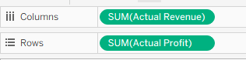

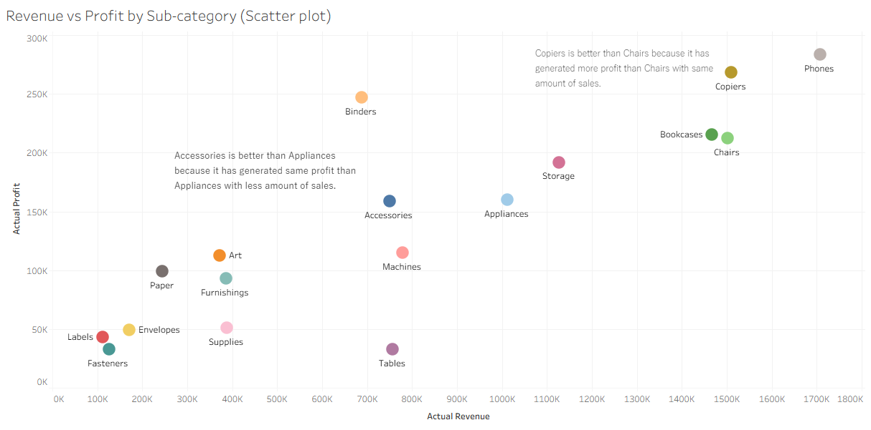
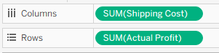
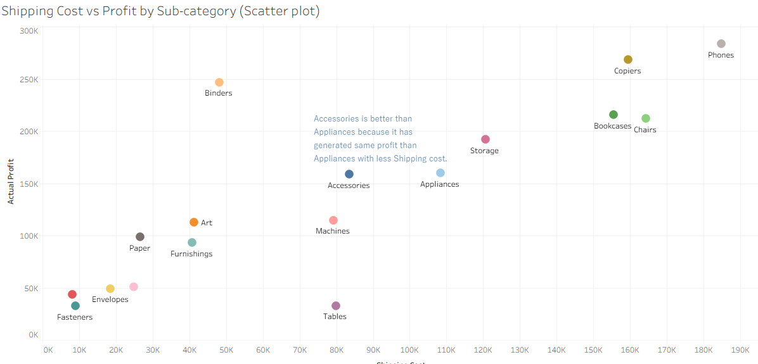
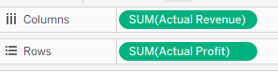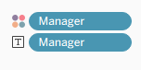
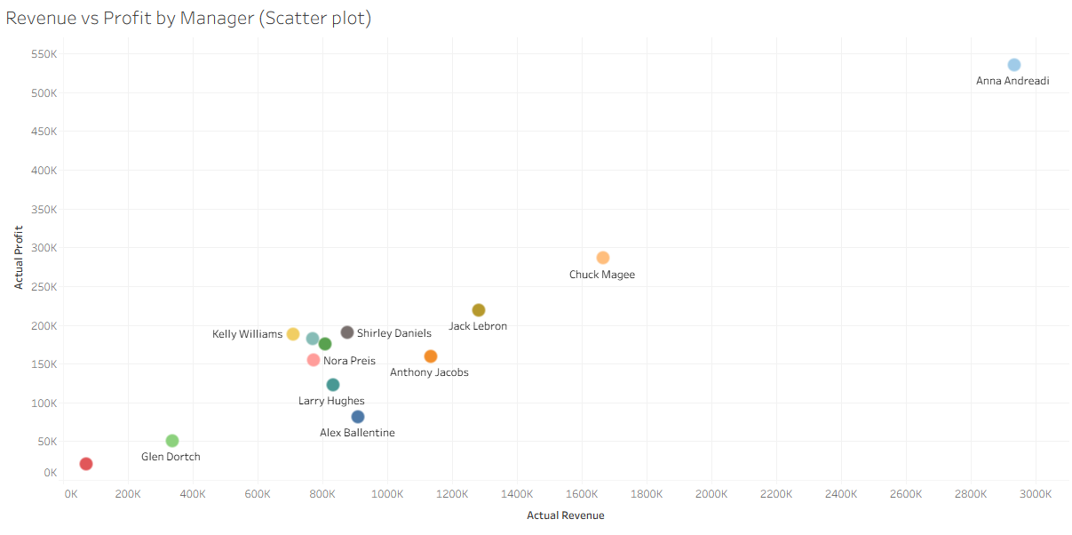
w/o aggregation
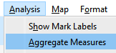
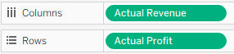
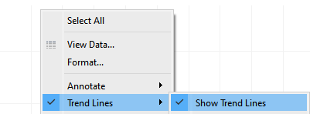
Hover over line 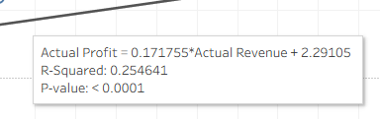
R square is 0.25 i.e. 25% variation in Y is due to variation in X. remaining 75% can be due to unknown factors.
Actual Profit = 0.1717 * Actual Revenue + 2.2910
If Revenue is 30k, what is Profit?
Profit ~ 5,153

Geographic charts
Two types-
- Symbol map (Default)
- Solid map
These charts can be using City, State (or County), Country, Pin Code, Airport, etc.
Symbol Map

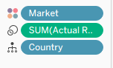
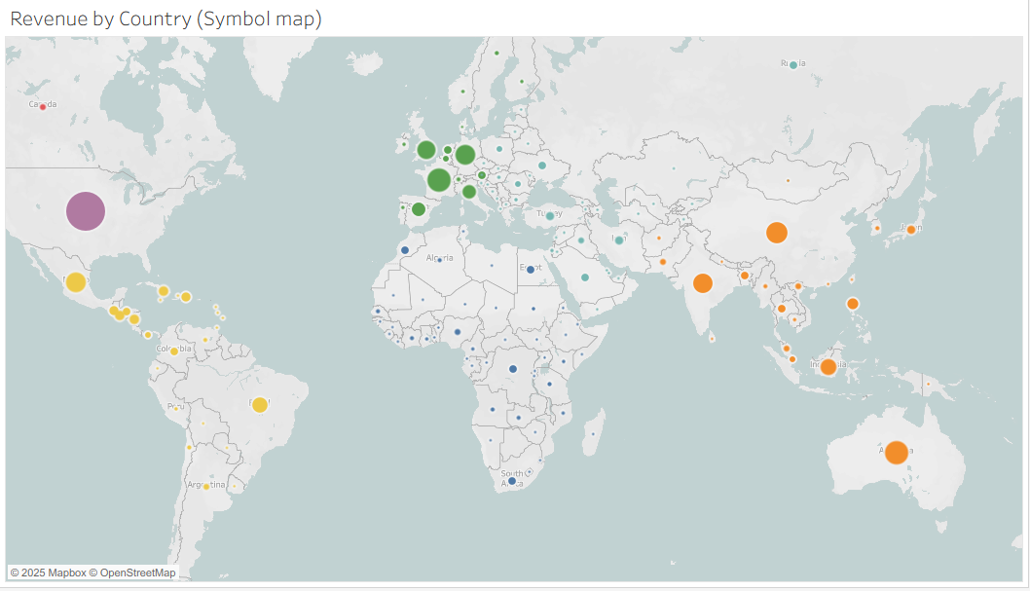
Revenue by Country (Symbol map)

1) Profit by Country (Symbol map) profit & loss in green & red resp.
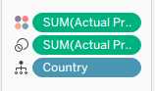
2) Quantity by Country (Symbol map)
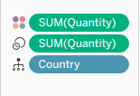
3) Shipping by Country (Symbol map)
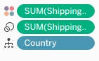
4) No. of Orders by Country (Symbol map)
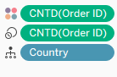
Using solid map of country & revenue, identify the countires where revenue is above 500k

Countries having revenue > 500k (Solid map)
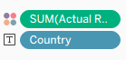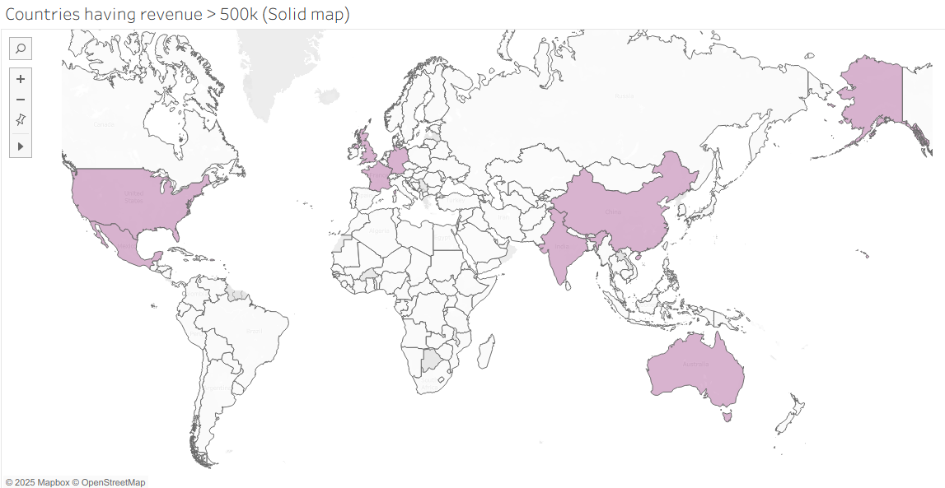
1) Build solid map of country & shipping cost. Show min/max values.
Countries with Shipping
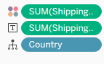
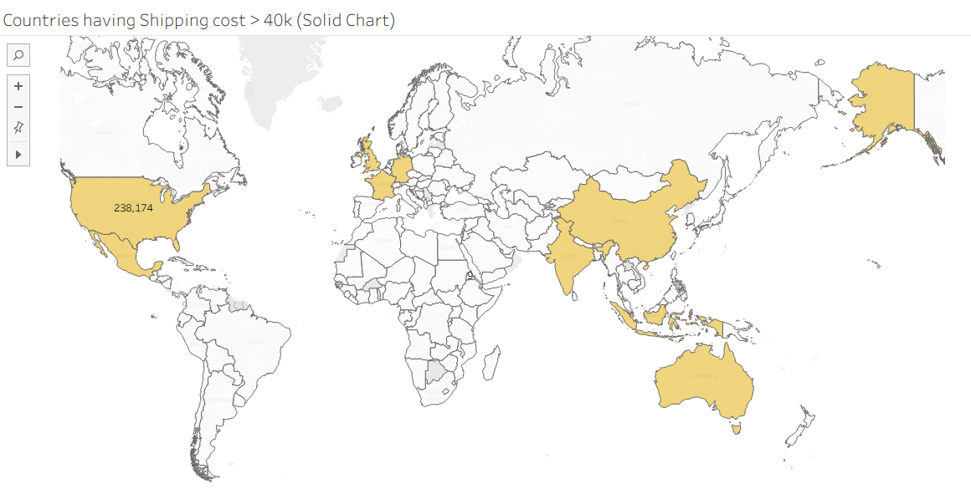
2) Build solid map of country of no. of orders. Show min/max values.
Orders by Country
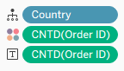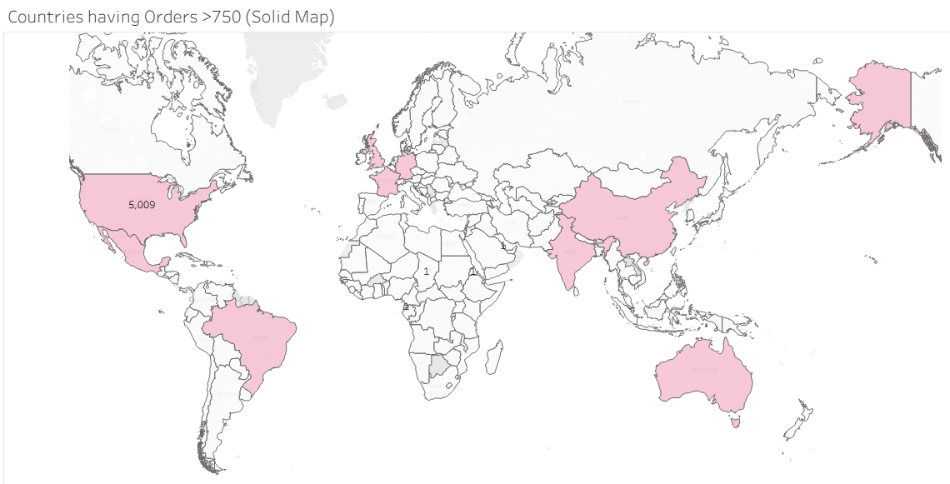

Histogram

Box Plot
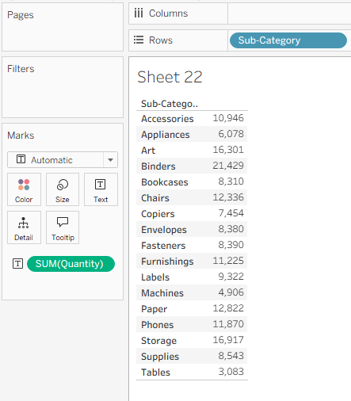
Click on
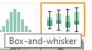
Horizontal
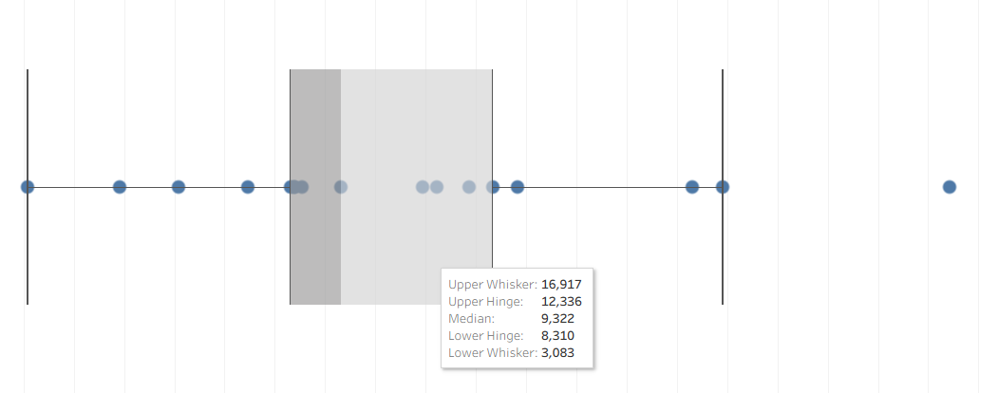
Quantity by Sub-category (Box plot)
Profit by Region and Order Priority (Box Plot)
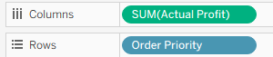
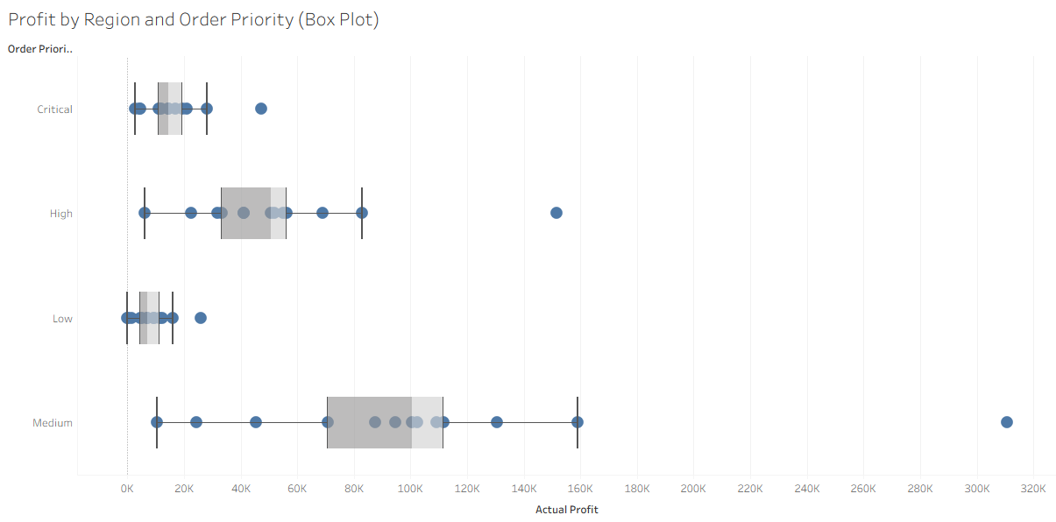
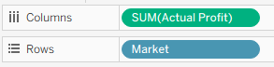

Profit by Sub-Category and Market (Box Plot)
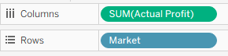
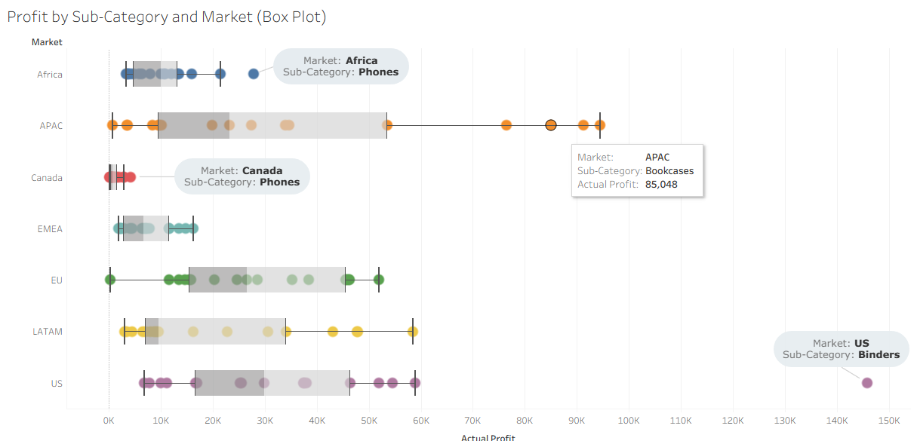

Heat Map
Identify combination of sub-category & manager having shipping cost above 10k
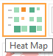
Shipping cost by Manager (Heat map)
Profit by Manager (Heat map)

------------------------------------
2 pie chart
2 bar chart
2 line chart (1 Discrete + 1 Continuous )
2 area chart (1 Discrete + 1 Continuous )
1 Histogram
-----------
Profit vs Loss by Gross Sales (Pie Chart)
Profit by Segment (Pie Chart)
--
Profit by Item & Country (100% Stack)
Profit Status by Item Name (Side by Side)
--
Monthly Profit (Discrete Line)
Monthly Profit (Continuous Line)
--

--

--

